-MOTIVE Social Media and Press-

Social Network
Motive Project Facebook page:
https://www.facebook.com/euprojectmotive

Other partner Facebook pages:
https://www.facebook.com/100779574904165/posts/201997044782417/
https://www.facebook.com/100779574904165/posts/201997044782417/?sfnsn=mo
https://m.facebook.com/story.php?story_fbid=1684482905064774&id=196572087189204&sfnsn=mo
https://www.facebook.com/100779574904165/posts/201997044782417/
https://www.facebook.com/incomagroup/posts/3205863949516108

News release regional TV Halong Meeting:
https://fb.watch/eozEqb4xCE/

Articles on National Journals:
https://tuoitre.vn/doi-theo-sinh-vien-ra-truong-20201124221522715.htm
https://www.tienphong.vn/giao-duc/he-thong-truy-vet-sinh-vien-tot-nghiep-thuoc-do-chat-luong-dai-hoc-1755326.tpo
https://baomoi.com/viec-lam-cho-sinh-vien-khi-ra-truong/c/37179080.epi
http://daidoanket.vn/viec-lam-cho-sinh-vien-khi-ra-truong-525251.html
https://www.giaoduc.edu.vn/he-thong-truy-vet-sinh-vien-tot-nghiep-thuoc-do-chat-luong-dai-hoc.htm
http://www.doanhtri.net/tin-doi-theo-sinh-vien-ra-truong--d67767.html
https://giaoducthoidai.vn/ket-noi/danh-gia-hieu-qua-viec-lam-sau-tot-nghiep-cua-sinh-vien-WTlY7yQMg.html
https://vietnamnews.vn/society/987425/itacentro-10-years-mark-of-connection.html
After interim report
https://dangcongsan.vn/.../giam-sat-xu-huong-tim-viec-lam...
http://truongnoivu.edu.vn/.../Truong-Dai-hoc-Noi-vu-Ha...
https://giaoducthoidai.vn/.../khai-mac-hoi-thao-giam-sat...
https://kinhtemoitruong.vn/dai-hoc-noi-vu-ha-noi-to-chuc...
https://vov.vn/.../nhieu-truong-dai-hoc-thong-ke-tren-80...
https://hoinhap.vanhoavaphattrien.vn/dai-hoc-noi-vu-ha...
https://vietnamhoinhap.vn/vi/hoi-thao-sinh-vien-tot-nghiep-va-thi-truong-lao-dong-tai-cong-hoa-y-37742.htm?zarsrc=31&utm_source=zalo&utm_medium=zalo&utm_campaign=zalo
https://kinhtemoitruong.vn/hoi-thao-sinh-vien-tot-nghiep-va-thi-truong-lao-dong-tai-cong-hoa-y-67205.html
https://vietnamhoinhap.vn/vi/danh-gia-cac-xu-huong-viec-lam-cua-sinh-vien-sau-tot-nghiep-tai-viet-nam-38940.htm
https://vietnamhoinhap.vn/vi/hoc-vien-hanh-chinh-quoc-gia-tham-du-hoi-thao-truyen-thong-du-an-motive-tai-thanh-pho-ho-chi-minh-45189.htm

News on Partners’ portals

Hanoi University website: Meeting with Project partners and other stakeholders (Central University of Pedagogy)– presentation of Erasmus+ MOTIVE Project 7 February 2020. Main scope: create networking opportunity and information exchange.
http://www.hanu.vn/vn/tin-tuc-su-kien/4792-truong-dai-hoc-ha-noi-to-chuc-cuoc-hop-cac-thanh-vien-tham-gia-du-an-motive.html

AlmaLaurea website: News Kick Off Meeting (February 2020)
https://www.almalaurea.it/en/informa/news/2020/02/19/motive-monitoring-trends-vietnamese-graduates-employment

Thay Nguyen University: online meeting 25 April 2020: KOM follow up for project presentation and implementation http://en.tueba.edu.vn/?p=1275

HUHA online meeting 25 April 2020: KOM follow up for project presentation and implementation
http://truongnoivu.edu.vn/tin-tuc/9720/Truong-Dai-hoc-Noi-vu-Ha-Noi-tham-du-tap-huan-trien-khai-Du-an-danh-gia-cac-xu-huong-viec-lam-cua-sinh-vien-da-tot-nghiep-tai-Viet-Nam-Motive.aspx

NUAE local meeting (1 July 2020): project implementation and post suspension activities to be carried out
http://www.spnttw.edu.vn/ArticleDetail.aspx?articleid=6512&sitepageid=624

Follow up MOTIVE Meeting (PTIT-November 23-26, 2020)
http://hanu.vn/vn/tin-tuc-su-kien/5188-hoi-thao-tap-huan-du-an-khao-sat-xu-huong-viec-lam-cua-sinh-vien-viet-nam-sau-tot-nghiep.html

https://portal.ptit.edu.vn/hoi-thao-tap-huan-du-an-khao-sat-xu-huong-viec-lam-cua-sinh-vien-viet-nam-sau-tot-nghiep/

https://ajc.hcma.vn/hop-tac-quoc-te/Pages/du-an-quoc-te.aspx?CateID=885&ItemID=12284

https://ajc.hcma.vn/hop-tac-quoc-te/Pages/du-an-quoc-te.aspx?ItemID=12738
http://hanoisme.vn/hanoisme-voi-du-an-motive.htm

http://tueba.edu.vn/bai-viet/Du-An-Motive-Co-Hoi-Cho-Sinh-Vien-Tueba-Tiep-Can-Voi-Nha-Tuyen-Dung-278.html

http://truongnoivu.edu.vn/tin-tuc/10056/HOI-THAO-TRUC-TUYEN-TRIEN-KHAI-DU-AN-DANH-GIA-CAC-XU-HUONG-VIEC-LAM-CUA-SINH-VIEN-DA-TOT-NGHIEP-TAI-VIET-NAM-MOTIVE-PROJECT-MEETING-MONITORING-TRENDS-IN-VIETNAMESE-GRADUATES-EMPLOYMENT-MOTIVE.aspx
http://www.spnttw.edu.vn/articledetail.aspx?sitepageid=624&articleid=6704

http://uhl.edu.vn/tin-tuc/hoi-thao-tap-huan-du-an-khao-sat-xu-huong-viec-lam-cua-sinh-vien-viet-nam-sau-tot-nghiep/

http://www.tnu.edu.vn/hoi-thao-tap-huan-du-an-khao-sat-xu-huong-viec-lam-cua-sinh-vien-viet-nam-sau-tot-nghiep-dn30978.html

https://1c.com.vn/vn/news/that-chat-lien-ket-giua-1c-viet-nam-va-cac-truong-dai-hoc

https://www.vnua.edu.vn/tin-tuc-su-kien/tin-hoat-dong-khac/hoi-thao-tap-huan-du-an-khao-sat-xu-huong-viec-lam-cua-sinh-vien-viet-nam-sau-tot-nghiep-51135

Follow up MOTIVE Meeting (NUAE March 22-25, 2021)

Dissemination channels of the event:
https://youtu.be/XcZCB4fMC-k

Motive Project Facebook page:
https://www.facebook.com/euprojectmotive/posts/335308948117892

News on National journal:
https://giaoducthoidai.vn/ket-noi/danh-gia-hieu-qua-viec-lam-sau-tot-nghiep-cua-sinh-vien-WTlY7yQMg.html

Posts on partners’ portal
http://www.spnttw.edu.vn/articledetail.aspx?articleid=6860&sitepageid=636

https://ajc.hcma.vn/hop-tac-quoc-te/Pages/du-an-quoc-te.aspx?CateID=885&ItemID=13239

https://vnua.edu.vn/tin-tuc-su-kien/tin-sinh-vien/hoi-thao-tap-huan-du-an-giam-sat-xu-huong-viec-lam-cua-sinh-vien-viet-nam-sau-tot-nghiep-thang-3-2021-51358

https://portal.ptit.edu.vn/hoi-thao-du-an-giam-sat-xu-huong-viec-lam-cua-sinh-vien-viet-nam-sau-tot-nghiep/

https://portal.ptit.edu.vn/eng/project-meeting-monitoring-trends-in-vietnamese-graduates-employment/

http://uhl.edu.vn/tin-tuc/hoi-thao-tap-huan-du-an-giam-sat-xu-huong-viec-lam-cua-sinh-vien-viet-nam-sau-tot-nghiep-thang-3-2021/

http://tnu.edu.vn/hoi-thao-tap-huan-du-an-giam-sat-xu-huong-viec-lam-cua-sinh-vien-viet-nam-sau-tot-nghiep-dn35101.html

http://truongnoivu.edu.vn/Tin-tuc/10181/Hoi-thao-truc-tuyen-trien-khai-Du-an-danh-gia-xu-huong-viec-lam-cua-sinh-vien-da-tot-nghiep-tai-Viet-Nam-MOTIVE.aspx

http://doanthanhnien.dhnv.edu.vn/vi/news/khoi-nghiep-lap-nghiep/hoi-thao-tap-huan-du-an-giam-sat-xu-huong-viec-lam-cua-sinh-vien-viet-nam-sau-tot-nghiep-320.html

http://tuoitrenoivu.net/vi/news/khoi-nghiep-lap-nghiep/hoi-thao-tap-huan-du-an-giam-sat-xu-huong-viec-lam-cua-sinh-vien-viet-nam-sau-tot-nghiep-320.html

https://www.facebook.com/Truongdaihocnoivuhanoi

http://truongnoivu.edu.vn/tin-tuc/10182/Hoi-thao-truc-tuyen-trien-khai-Du-an-danh-gia-xu-huong-viec-lam-cua-sinh-vien-da-tot-nghiep-tai-Viet-Nam-MOTIVE.aspx

Posts on other stakeholders’ portal (new universities)
https://utb.edu.vn/hoat-dong/tin-tuc/357-hoi-thao-cach-thuc-su-dung-du-lieu-khao-sat-sinh-vien-tot-nghiep-de-ho-tro-cai-cach-quan-tri-va-dam-bao-chat-luong-tai-truong-dai-hoc.html

Follow up MOTIVE Meeting (VNUA June 22-25, 2021)
https://www.facebook.com/100779574904165/posts/335308948117892/

Follow up MOTIVE Meeting (TNU October 26-29, 2021)
https://m.facebook.com/story.php?story_fbid=416831449965641&id=100779574904165&m_entstream_source=timeline&ref=page_internal

http://truongnoivu.edu.vn/tin-tuc/10460/Hoi-thao-va-tap-huan-truc-tuyen-Du-an-MOTIVE-Cach-thuc-khao-sat-tinh-trang-viec-lam-cua-sinh-vien-tot-nghiep-tai-cac-co-so-dai-hoc-trong-boi-canh-Dai-dich-Covid19.aspx

http://tuoitrenoivu.net/vi/news/tintuc-sukien/hoi-thao-va-tap-huan-truc-tuyen-du-an-motive-cach-thuc-khao-sat-tinh-trang-viec-lam-cua-sinh-vien-tot-nghiep-tai-cac-co-so-dai-hoc-trong-boi-canh-dai-dich-covid-19-410.html

Follow up MOTIVE Meeting (HUHA branch March 2022)

http://spnttw.edu.vn/articledetail.aspx?sitepageid=624...

https://dangcongsan.vn/.../giam-sat-xu-huong-tim-viec-lam...

https://hoinhap.vanhoavaphattrien.vn/dai-hoc-noi-vu-ha...

http://truongnoivu.edu.vn/tin-tuc/10609/Truong-Dai-hoc-Noi-vu-Ha-Noi-to-chuc-Hoi-thao-tap-huan-Du-an-Giam-sat-xu-huong-tim-viec-lam-cua-sinh-vien-tot-nghiep-tai-Viet-Nam.aspx
https://hoinhap.vanhoavaphattrien.vn/dai-hoc-noi-vu-ha-noi-to-chuc-hoi-thao-giam-sat-xu-huong-viec-lam-cua-sinh-vien-tot-nghiep-a7813.html

https://nongthonvaphattrien.vn/dai-hoc-noi-vu-ha-noi-to-chuc-hoi-thao-giam-sat-xu-huong-viec-lam-cua-sinh-vien-tot-nghiep-a528.html

https://doisongvaphattrien.vn/dai-hoc-noi-vu-ha-noi-to-chuc-hoi-thao-giam-sat-xu-huong-viec-lam-cua-sinh-vien-tot-nghiep-a43788.html

https://dangcongsan.vn/giao-duc/giam-sat-xu-huong-tim-viec-lam-cua-sinh-vien-tot-nghiep-tai-viet-nam-605996.html

https://giaoducthoidai.vn/ket-noi/khai-mac-hoi-thao-giam-sat-xu-huong-tim-viec-lam-cua-sinh-vien-tot-nghiep-02KqoDEnR.html

https://kinhtemoitruong.vn/dai-hoc-noi-vu-ha-noi-to-chuc-hoi-thao-giam-sat-xu-huong-tim-viec-lam-cua-sv-tot-nghiep-tai-vn-65136.html

https://vov.vn/xa-hoi/giao-duc/nhieu-truong-dai-hoc-thong-ke-tren-80-sinh-vien-co-viec-lam-kho-kiem-dinh-post930638.vov

https://huha.edu.vn/en/news/training-activities/hanoi-university-of-home-affairs-held-a-training-workshop-on-the-project-monitoring-trends-in-vietnamese-employment-52.html

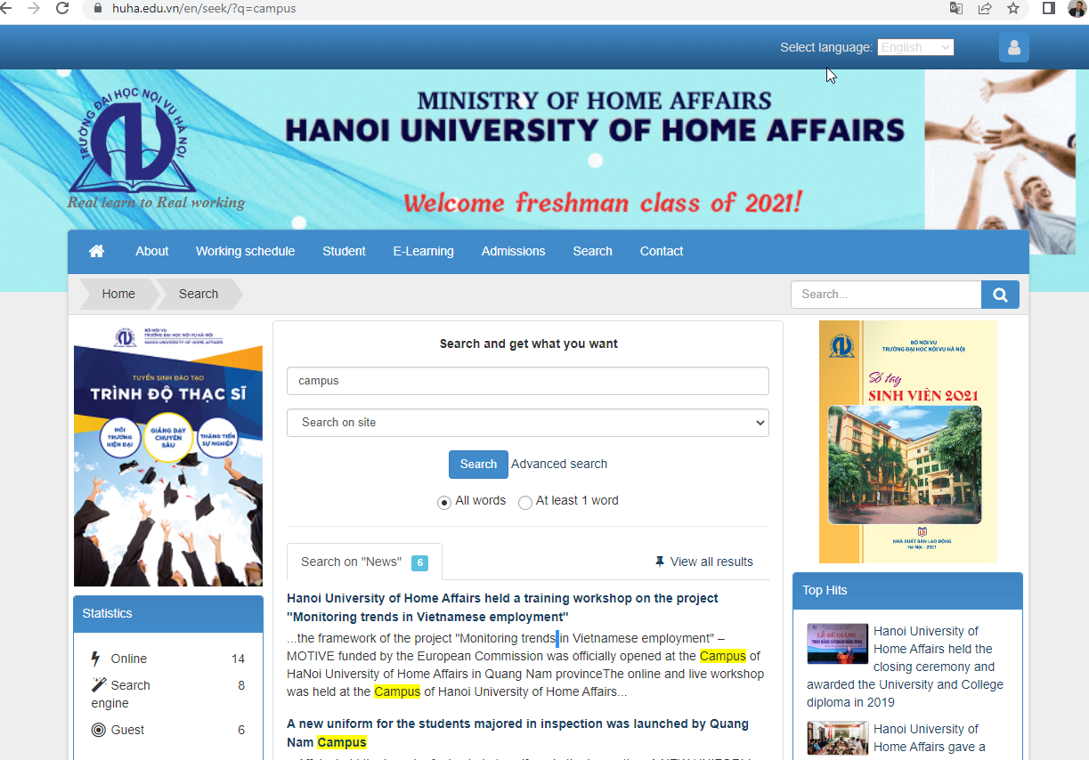

Follow up MOTIVE Meeting (Bologna, May 2022)

https://vietnamhoinhap.vn/vi/hoi-thao-sinh-vien-tot-nghiep-va-thi-truong-lao-dong-tai-cong-hoa-y-37742.htm?zarsrc=31&utm_source=zalo&utm_medium=zalo&utm_campaign=zalo

https://kinhtemoitruong.vn/hoi-thao-sinh-vien-tot-nghiep-va-thi-truong-lao-dong-tai-cong-hoa-y-67205.html

Follow up HALOU meeting(Uong Bi, July 2022)
https://vietnamhoinhap.vn/vi/danh-gia-cac-xu-huong-viec-lam-cua-sinh-vien-sau-tot-nghiep-tai-viet-nam-38940.htm
https://www.almalaurea.it/informa/news/2022/07/20/motive-erasmus-project-meeting-di-disseminazione-e-workshops
https://www.almalaurea.it/en/informa/news/2022/07/20/motive-erasmus-project-dissemination-event-and-workshops

http://tnu.edu.vn/hoi-thao-bo-cong-cu-tu-danh-gia-nang-luc-cot-loi-dat-duoc-trong-qua-trinh-dao-tao-dn48617.html
https://sfl.tnu.vn/hoi-thao-quoc-te-bo-cong-cu-tu-danh-gia-nang-luc-cot-loi-dat-duoc-trong-qua-trinh-dao-tao-thuoc-khuon-kho-du-an-motive/

News release regional TV Halong Meeting: project website:
https://fb.watch/eozEqb4xCE/

Follow up HTC meeting (Hanoi, September 2022)

https://htc.edu.vn/rss/index.php?pageid=13879&topicid=15

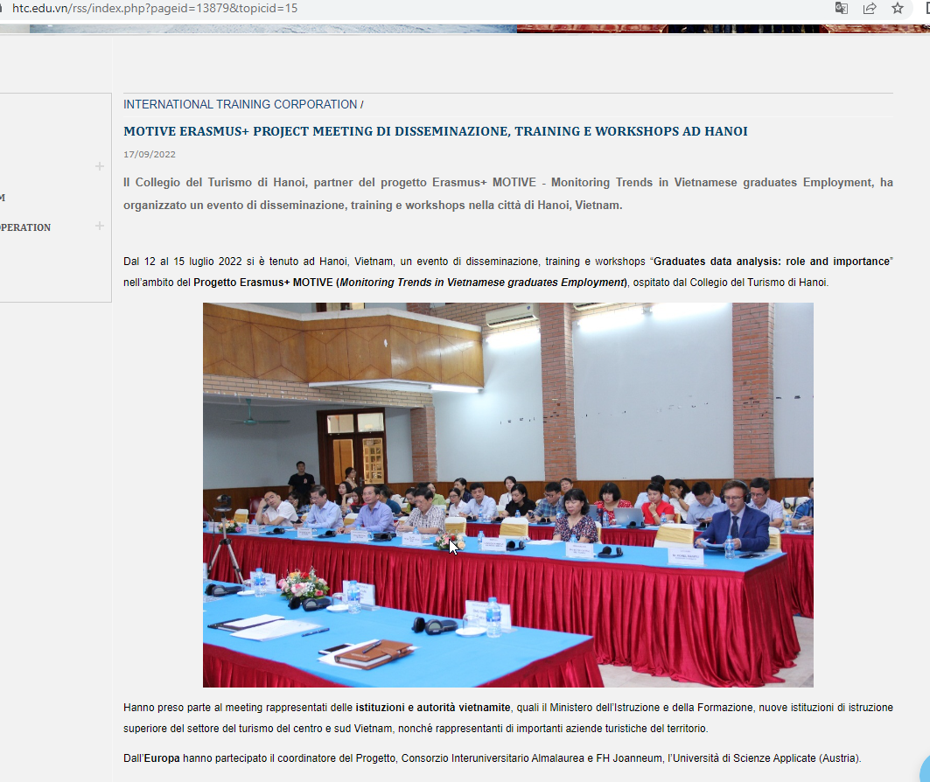

https://www.facebook.com/euprojectmotive?__cft__[0]=AZVHpc0eMYCSRtakscdynpkfk_9bI0EZWThN98ZAmbX1F4sQe5umrHigisoZFDBG_l-c0ITyJT_1ldnDdH2TScib2EfQNhk5zF6v79ca9ApITu82ur0g8JC76aVFgW1VFEJJZ-dmX3EkVe4MkrQaj3_vhxLKnwNuzkmO-jEXaPjUZA&__tn__=-UC%2CP-R

https://www.almalaurea.it/en/news/motive-erasmus-project-dissemination-event-training-and-workshops

https://www.almalaurea.it/news/motive-erasmus-project-meeting-disseminazione-training-workshops-hanoi

Follow up AJC meeting (Hanoi, October-November 2022)

Motive Project - Hội thảo "Chính sách dựa trên minh chứng... | Facebook
https://www.almalaurea.it/news/conferenza-hanoi-progetto-motive

https://www.almalaurea.it/en/news/motive-erasmus-project-conference-in-hanoi

https://en.nhandan.vn/conference-on-evidence-based-policy-and-higher-education-held-in-hanoi-post119409.html

Follow up FH Joanneum meeting (Graz, March 2023)

https://www.almalaurea.it/en/news/motive-erasmus-project-workshop-capacity-building-survey-reporting

https://www.almalaurea.it/news/motive-erasmus-project-workshops-capacity-building-survey-reporting

Học viện Hành chính Quốc gia tham dự Hội nghị tập huấn Dự án MOTIVE chủ đề “Xây dựng năng lực báo cáo khảo sát” tại Cộng hòa Áo | HỌC VIỆN HÀNH CHÍNH QUỐC GIA (napa.vn)

NAPA ATTENDS THE MOTIVE PROJECT MEETING “CAPACITY BUILDING ON SURVEY REPORTING” | National Academy of Public Administration

Follow up Ho Chi Minh City dissemination event (Ho Chi Minh City, September 2023)

Video meeting presentation:
https://www.youtube.com/watch?v=oH08U-W8ZQI&t=138s

https://drive.google.com/drive/folders/1CeM6X1OlISH9RaPS5mEHr1WDrXyt6PS2?usp=sharing

News on national journal
https://vietnamhoinhap.vn/vi/hoc-vien-hanh-chinh-quoc-gia-tham-du-hoi-thao-truyen-thong-du-an-motive-tai-thanh-pho-ho-chi-minh-45189.htm

News on websites
https://www.almalaurea.it/news/erasmus-motive-vietnam-settembre-2023

https://www.almalaurea.it/en/news/erasmus-motive-vietnam-september-2023

https://portal.ptit.edu.vn/hoi-thao-pho-bien-ket-qua-du-an-khao-sat-xu-huong-viec-lam-cua-sinh-vien-viet-nam-sau-tot-nghiep/

https://vnua.edu.vn/tin-tuc-su-kien/hop-tac/hoc-vien-nong-nghiep-viet-nam-tham-du-hoi-thao-motive-theo-doi-xu-huong-viec-lam-cua-sinh-vien-sau-khi-tot-nghiep-tai-cac-truong-dai-hoc-cua-viet-nam-54299

http://tnu.edu.vn/hoi-thao-pho-bien-ket-qua-du-an-khao-sat-xu-huong-viec-lam-cua-sinh-vien-viet-nam-sau-tot-nghiep-dn70470.html

https://uhl.edu.vn/tin-tuc/can-bo-giang-vien-truong-dai-hoc-ha-long-tham-du-du-an-khao-sat-xu-huong-viec-lam-cua-sinh-vien-viet-nam-sau-tot-nghiep-motive-tai-thanh-pho-ho-chi-minh/

https://hanu.edu.vn/a/129167/Hoi-thao-pho-bien-ket-qua-Du-an-khao-sat-xu-huong-viec-lam-cua-sinh-vien-Viet-Nam-sau-tot-nghiep/

https://www1.napa.vn/blog/hoc-vien-hanh-chinh-quoc-gia-tham-du-hoi-thao-truyen-thong-du-an-motive-tai-thanh-pho-ho-chi-minh.htm

http://tnu.edu.vn/hoi-thao-pho-bien-ket-qua-du-an-khao-sat-xu-huong-viec-lam-cua-sinh-vien-viet-nam-sau-tot-nghiep-dn70470.html

https://hanoisme.vn/hanoisme-dong-hanh-cung-du-an-motive.htm

https://www.qtsc.com.vn/tin-tuc/doan-can-bo-giang-vien-du-an-motive-lam-viec-tai-qtsc

Motive Project Facebook page:
https://www.facebook.com/euprojectmotive/posts/pfbid02bo1P3tWLXep4xH8d9EtG6LmCHKeSRLMR4TZUKFhBhHN7NYwRwniZFX2Cb3bdHUx7l?__cft__[0]=AZXlm2vpPQ7P6_25YQ8tj_I2omQD47_GioPblq4TORq2_htxud_8V7Am6-RaPHsoCkc76gZtQCT-fXxSLE30Je-ivcp9bLVrj9H-XvE_wy8IOpT0sfKfA9k-Ovd-3xBYUa0wQgV27F3ipcQZMUiMbaTL8ru8DAcjQivG2r44RIE7OjLHT-Bvz2kAhUYIwOE0vbIHgQzEoO0WNoo-mYyfozIw&__tn__=%2CO%2CP-R

