SELECTION FOR EXTERNAL EXPERT ON QUALITY – MOTIVE PROJECT

Erasmus + 609781 MOTIVE Project website:

https://motive-euproject.net/events/selection-procedure-for-external-expert/

Facebook

https://www.facebook.com/100779574904165/posts/157790592536396/?sfnsn=scwspmo&extid=oSSbqq0XDWoXLuYe

https://www.facebook.com/100779574904165/posts/157805445868244/?sfnsn=scwspmo&extid=SThBAFYl34fytlg4

Italy:

AlmaLaurea Interuniversity Consortium (Coordinator):
https://www.almalaurea.it/info/chisiamo/lavoraconnoi/consorzio/posizioni_aperte

Austria:
FH JOANNEUM (partner)
Dear Dorel,
I hope that you and your family and friends got well through the crisis.
It is good to hear that we restart!
I have posted your call on my linkedin profile (>1100 contacts, many from EU project management sphere).
It makes much more sense then publishing it on our website, I hope that is ok for you (a screenshot is attached).
BR from Graz, Rupert.
FH JOANNEUM Gesellschaft mbH
Rechtsform/Legal form: GmbH
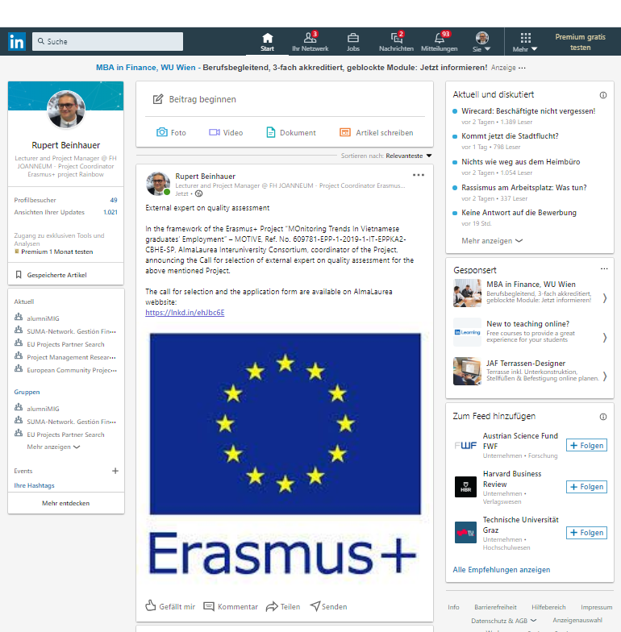

Spain:

https://www.linkedin.com/feed/update/urn:li:activity:6684751646863454208

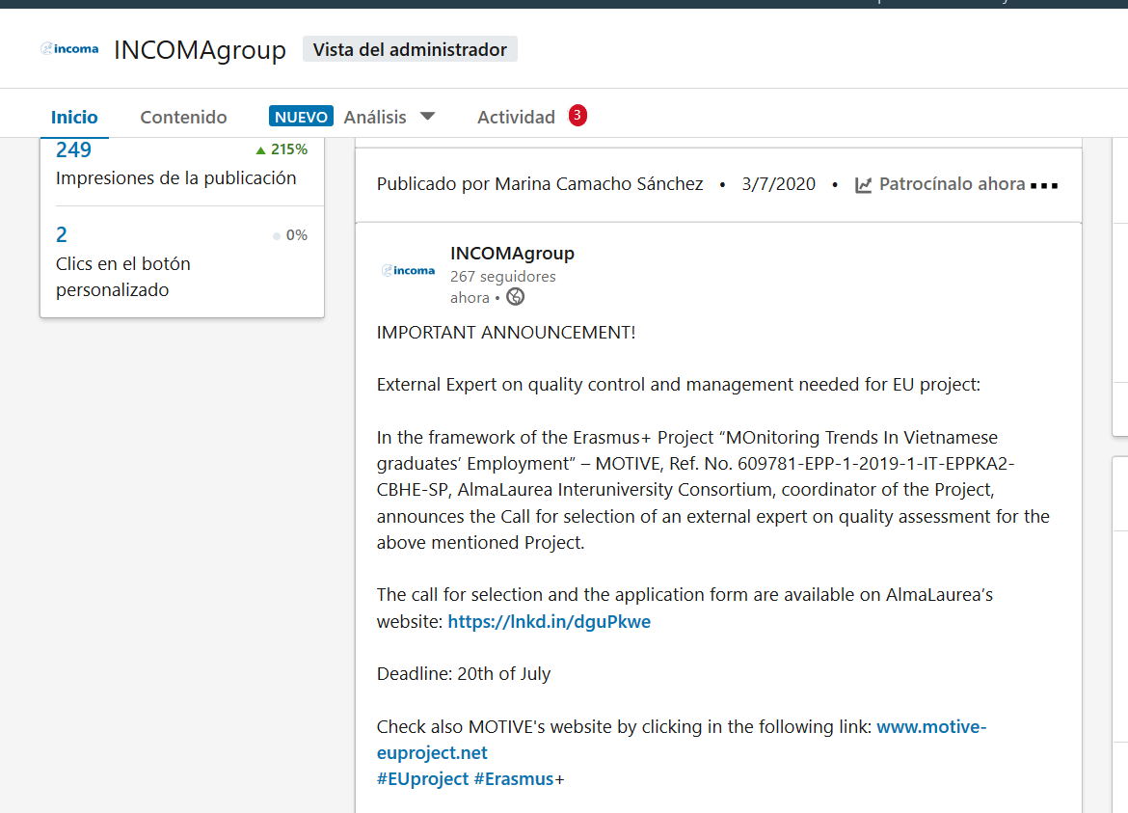

Vietnam:

National coordinator Hanoi University HANU, Hanoi, Vietnam:
http://hanu.vn/vn/du-an-quoc-te/269-du-an-quoc-te/d-an-motive/4972-call-for-selection-of-external-expert-on-quality-assessment.html

Posts and Telecommunications Institute of Technology PTIT, Hanoi, Vietnam:
https://portal.ptit.edu.vn/eng/call-for-selection-of-external-expert-on-quality-assessment-for-the-erasmus-project-motive/?fbclid=IwAR0eN2Zctdym_xY-A9aCoXlaStPXd5zciJHvfdioN4viSx2lE5A_soL01kM

Thai Nguyen University TNU– Thai Nguyen City, Vietnam
http://en.tnu.edu.vn/recruitment-dt563.html

AJC
https://ajc.hcma.vn/hop-tac-quoc-te/Pages/du-an-quoc-te.aspx?CateID=885&ItemID=12293

HTC
https://htc.edu.vn/rss/index.php?pageid=13275&topicid=15&pagenum=1

TNU
http://en.tnu.edu.vn/recruitment-dt563.html

HUHA
http://truongnoivu.edu.vn/tin-tuc/9818/Thong-tin-tuyen-dung-vi-tri-tri-Chuyen-gia-kiem-dinh-chat-luong-cho-Du-an-Erasmus.aspx

NUAE
http://spnttw.edu.vn/articledetail.aspx?articleid=6516&sitepageid=720

VNUA
https://eng.vnua.edu.vn/notification/our-organization-vietnam-national-university-of-agriculture-is-a-partner-of-motive-project-50815

