MOTIVE PROJECT

Project No. 609781-EPP-1-2019-IT-EPPKA2-CBHE-SP

“MOnitoringTrends in Vietnamese graduates’ Employment”

PROJECT MEETING

"How to use graduates surveys on data for supporting governance reform and QA in Higher Education" (WP4.1)

Hanoi, 22-25 June 2021

Vietnam National University of Agriculture
(VNUA)

Hanoi, Vietnam

Zoom ID:
MEETING AGENDA

PROJECT CONSORTIUM

PROGRAMME COUNTRIES

1.Consorzio Interuniversitario AlmaLaurea – coordinator (ALMALAUREA), Italy

2.FH JOANNEUM, University of Applied Sciences (FH JOANNEUM), Austria | 3.Universitat de Barcelona (UB), Spain  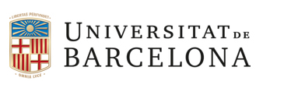
4.International Consulting and Mobility Agency (INCOMA), Spain | 5.Agencia Nacional de Evaluacion de la Calidad y Acreditacion (ANECA), Spain  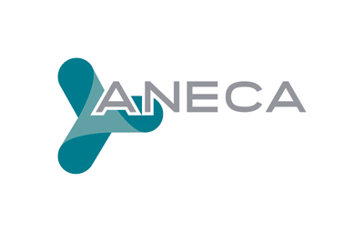

PARTNER COUNTRY
6.Hanoi University (HANU), Vietnam | 7.Posts and Telecommunications Institute of Technology (PTIT), Vietnam
8.National University of Art Education (NUAE), Vietnam  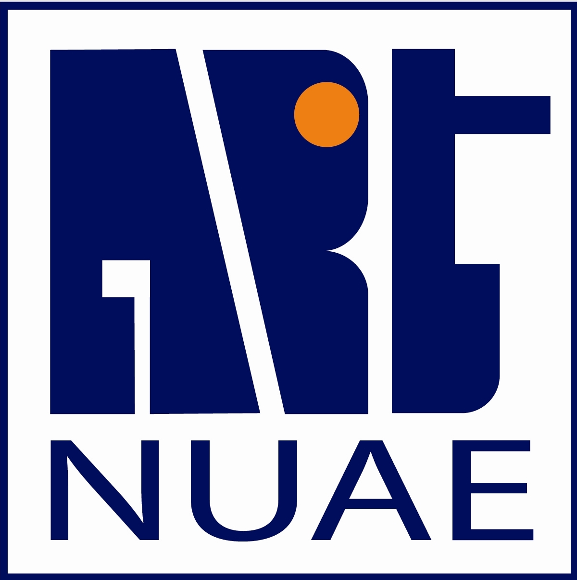 | 9.Vietnam National University of Agriculture (VNUA), Vietnam
10.Thai Nguyen University (TNU), Vietnam | 11.Academy of Journalism and Communication (AJC), Vietnam  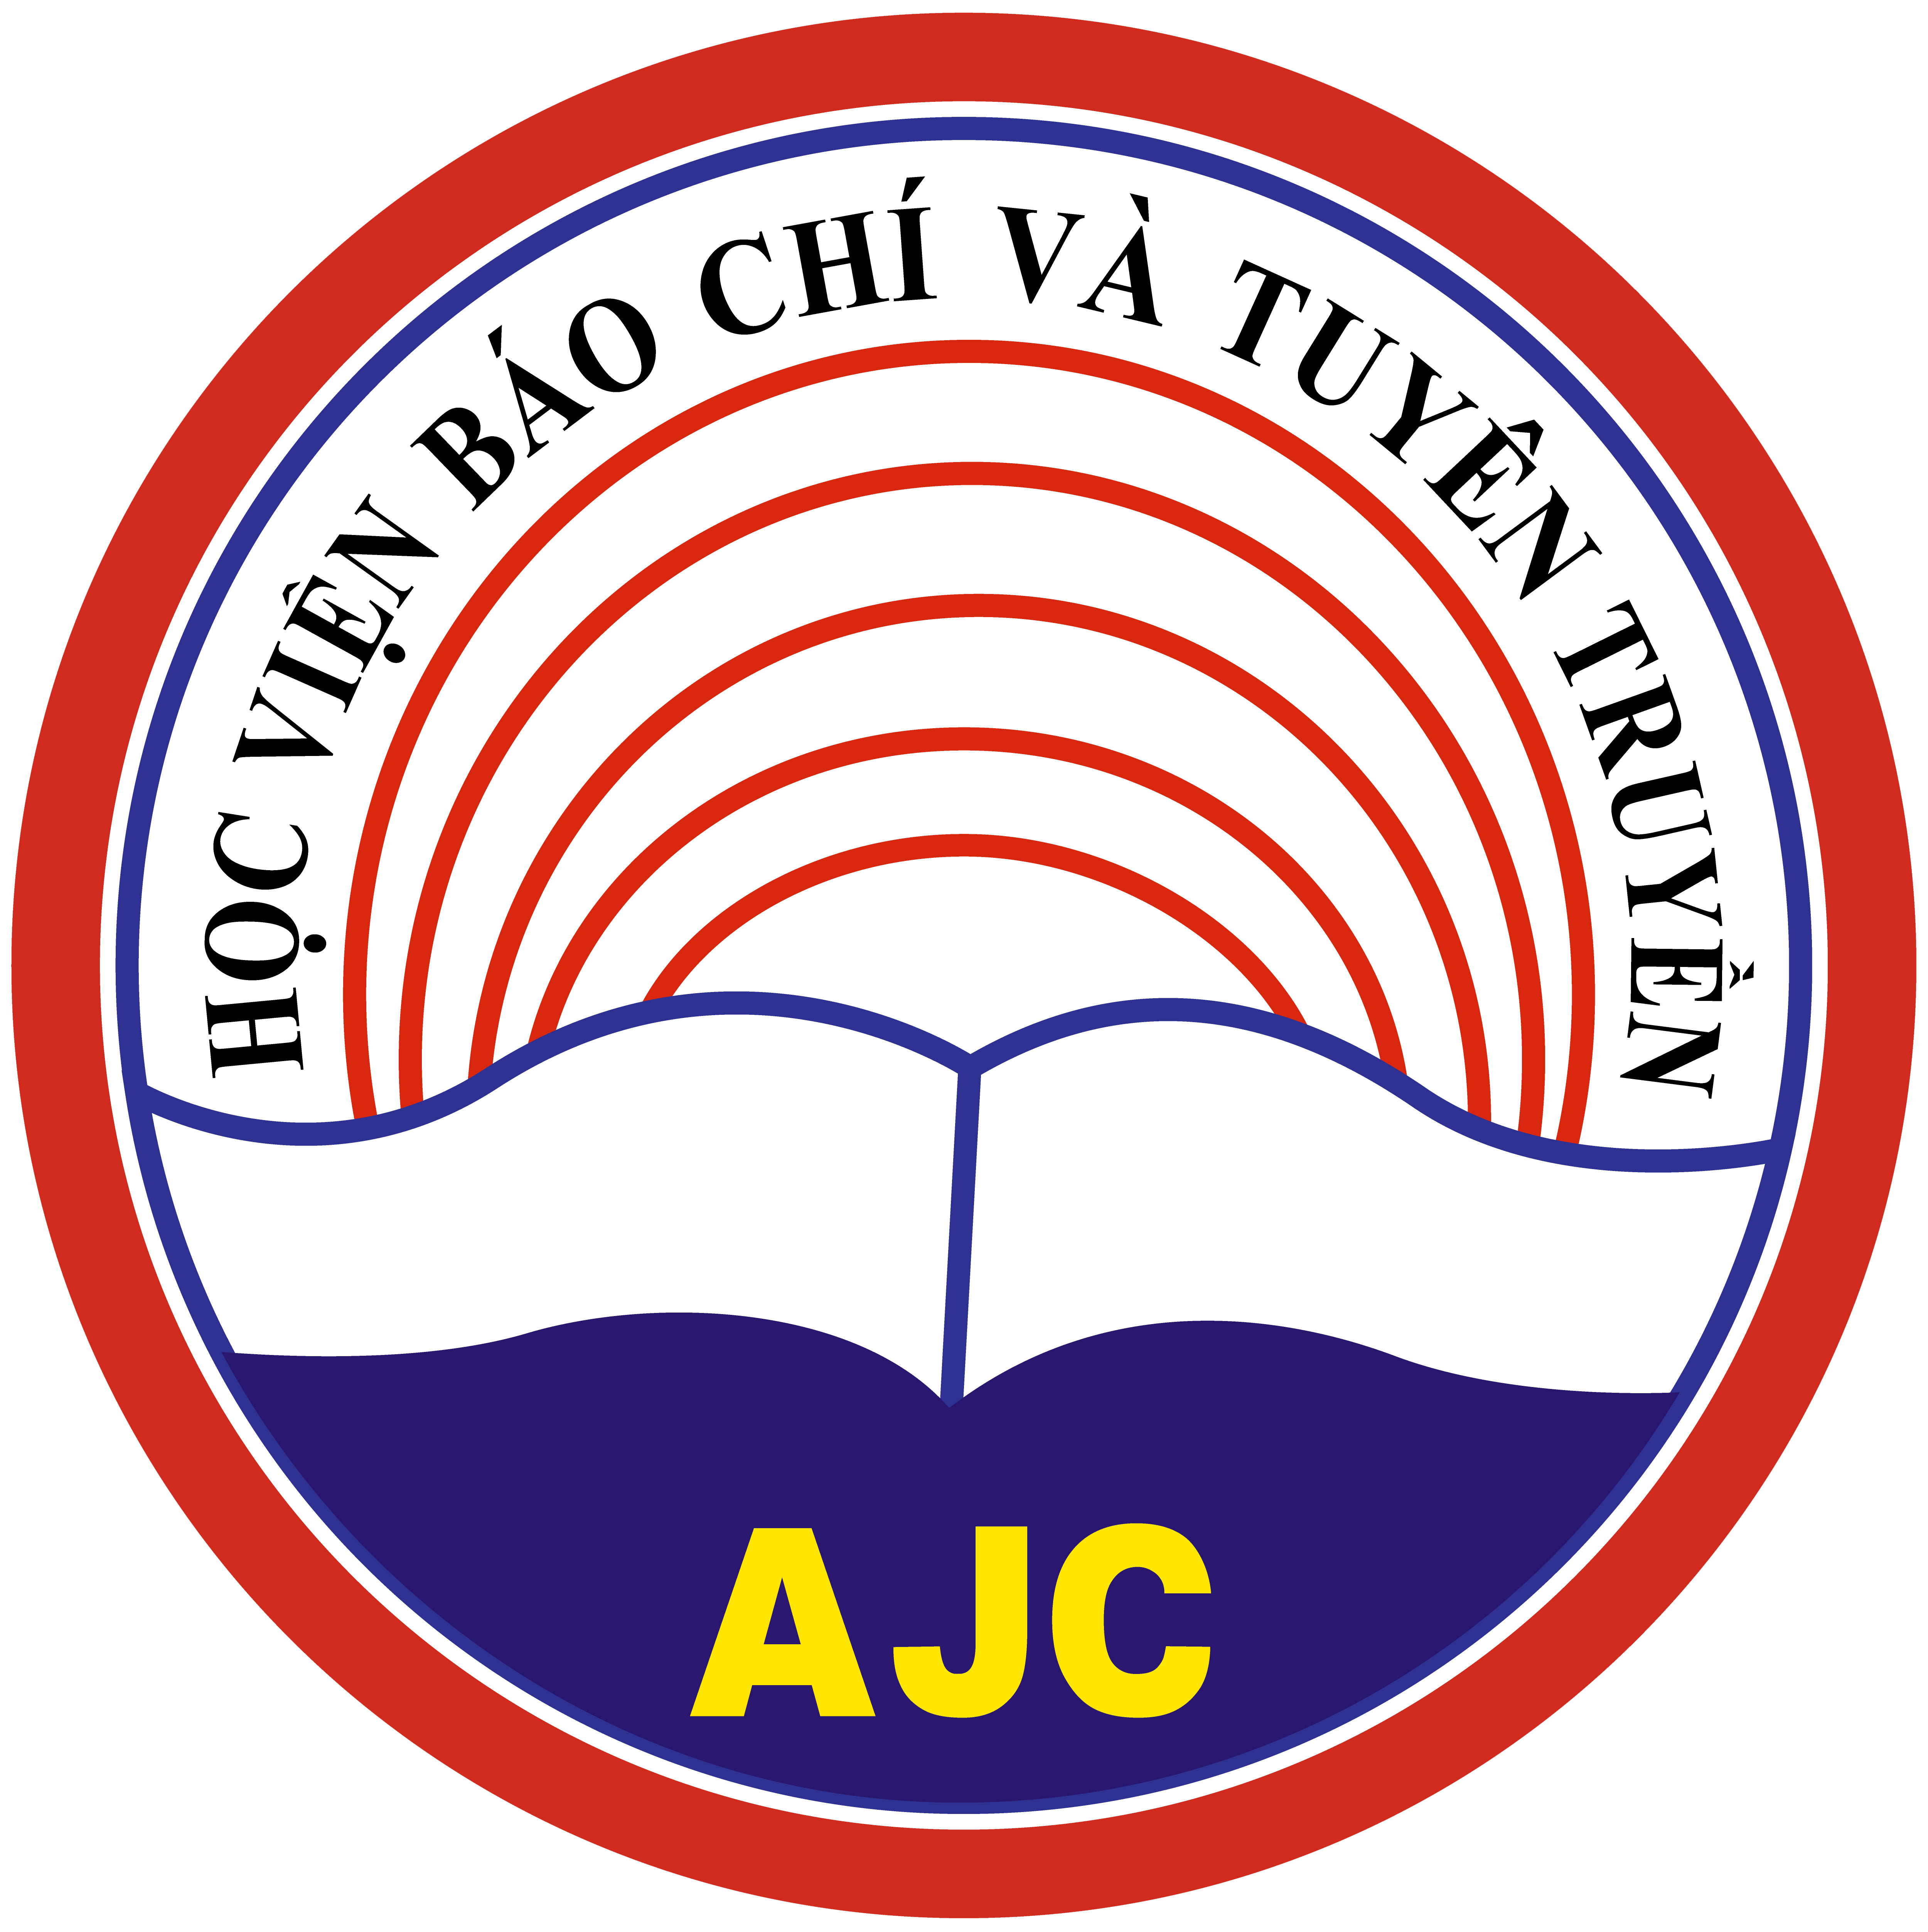
12.Hanoi University of Home Affairs (HUHA), Vietnam | 13.Hanoi Tourism College (HTC), Vietnam
14.Halong University (HALOU), Vietnam | 15.Ministry of Education and Training (MOET), Vietnam
16.Hanoi Small and Medium Enterprises Association (HanoiSME), Vietnam | Associate partners: Ho Chi Minh Open City University (OU),Vietnam;Italian Chamber of Commerce in Vietnam  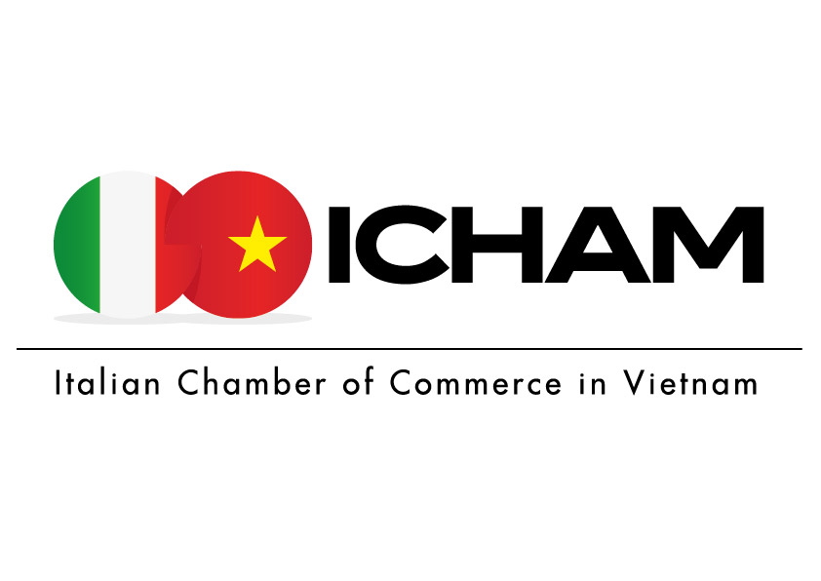

-MOTIVE Project Consortium dissemination workshop-
22 June 2021

9.00 - 9.30 | Registration of participants
9.30 –11.00 | Reviewing the preparation: content, equipment for the seminar  MOTIVE Project Dissemination strategies: presentation of best practices (I)  -partners
11.00 - 11.30 | break
11.30 –13.00 | Introduction to the meeting  Dang Thi Phuong Thao, HANU – National coordinator + Hoang Thu Thuy HANU  -partners
13.00 – 14.00 | Lunch break
15.00 – 17.00 | Management meeting with Vietnamese partners  Staff characteristics for the MOTIVE Project  Dang Thi Phuong Thao, HANU – National coordinator  Workshop with Country partner participants  Role of staff categories in the Project and instruction regarding the reporting period:  - Managers  - Researchers/Teachers/Trainers  - Technicians  - Administrative staff  16.15 – 17.00: Q&A and Conclusion
Vietnamese-English and English-Vietnamese simultaneous translationavailable

-MOTIVE Workshop and dissemination event-
23 June 2021

8.30–9.00 | Registration of participants
9.00 – 12.30 | Workshop on WP 2.2: Graduates tracking: scope and questionnaire definition (follow up of NUAE meeting)  Moderator: Ngo Phuong Dung and HANU research team  Topics:  A) Platform to be used for survey: Google form – each University will have its own link in order to collect its own data (Confidentiality topic)  B) Analysis of the Ministry request: survey at 1 year after graduation (as decided at NUAE meeting: to be surveyed 2020 graduates)  C) Questionnaire approval: discussion on compulsory indicators (MOET request) and eventual specific questions to be added
12.30 – 14.30 | Lunch
14.30 – 17.30 | WP 5.2 Dissemination event  EU partners connects to Meeting online, external stakeholders  Welcome address  14.30 - 14.40: Prof. Dr Nguyen Thi Lan – President of VNUA  14.40 – 14.50: Ass Prof. Dr Nguyen Ba Chien – Rector of HUHA  14:50 – 15:00: Dr. Dorel Manitiu - Interuniversity Consortium Almalaurea  15:00 – 15:15: Some results on MOTIVE project in Vietnam since the NUAE conference: Dr. Chu Anh Tiep – Scientific committee  15:15 - 15-45: WP 4 “Enhancing staff capabilities to support the reform policies”  Moderator : ANECA  Launching of the call for papers ( WP 4.2)  Dorel Manitiu, AlmaLaurea  How to use graduates surveys on data for supporting governance reform and QA in Higher Education (WP 4.1)  15.45-16.15: Graduates Tracking - suggestions for further steps and survey  Silvia Galeazzi, Claudia Girotti (AlmaLaurea)  16.15-17.00: Quality assurance mechanisms and approaches and its governance within the Vietnamese institutions  National Agency for Quality Assurance (ANECA)  17:00 – 17.30: Q&A and Conclusion
Vietnamese-English and English-Vietnamese simultaneous translation available

-Researcher, IT and administrative staff meeting-
24 June 2021

09.00 – 12.30 | Technical meeting – follow up of WP 2  Moderator: HANU Research and IT team  Data collection method:  - Each university will have its own link for the survey; each university will clean the data and make the file “anonymous”  - IT solution for merge the aggregate data of all Universities (no graduates names, no University names, no Department names)  - Decision on how and who will collect the data in order to remain anonymous  Report  - The report will be drafted in aggregate way for all universities involved: the description of the indicators present in the questionnaire will give an aggregate picture of the Vietnamese graduates employment status  - Each university will send its own report to MOET, with respect of Confidentiality of data  WP.6 Center for Graduates Tracking: general structure definition  HANU IT staff will suggest possibilities for creation of the portal  Topics:  -Portal domain: motive.hanu.vn?? graduatetracking.hanu.vn?? other??  Contents of the portal:  -information about the center and its mission;  -structure of the center and management;  -national Center’staff;  -functions and Services;  -main publication (Graduates Tracking and Graduates Profile Survey);  -Working Paper Series;  -how to join;  -database on Center’ National Stakeholders (stakeholders network: new companies, new unievrsities, other associations, etc)
12.30 – 14.30 | Lunch
14.30 – 15.30 | WP 5 Handbook f best practices  Moderator: Almalaurea, JSC, VNUA  WP 5.4 Presentation of the state of art of "Handbook of best practices for dissemination"  AlmaLaurea  Open discussion  Project Consortium
15:30-17:00 | - Sharing experiences in implementing the MOTIVE project of HALOU  - Sharing experiences in implementing the MOTIVE project of TNU  - Discuss the implementation plan on all of Universities to support students to register and create MOTIVE CV on motive.edu.vn  MC: Mr. Huan - VNUA
17:00 – 17:30 | Results of expansion of the MOTIVE project to Universities and Colleges in Vietnam.  Dr. Chu Anh Tiep - Scientific committee
Vietnamese-English and English-Vietnamese simultaneous translation available

- Financial meeting -
25 June 2021

09.00 – 9.30 | Introducing the MOTIVE project to new universities and combaníe  Dr. Chu Anh Tiep - Comitato Scientifico
9:30 – 9:50 | Statements of some university and expectations to deverlopment with MOTIVE  Phu Xuân University (PXU)  Tây Bắc University (TBU)
9:50 – 10:20 | Statements of Copanies in finding humen resources, expectations from the MOTIVE system  - CP Vietnam Corporation  - Nicotex Joint Stock Company  -
10:20 – 10:30 | Tea brecks
10:30-1130 | Discussing the connecting companies and students joint MOTIVE webside for building CV  MC: Tiệp - VNUA
11:30-12:00 | Discuss the managemnet and access to use on motive.edu.vn  Mr. Dương - HANU
 | Lunch
14:30-15:15 | Discussion of the WP 4.2. Launch of the writing contest for students from the universities of the MOTIVE project joint “Graduations and the labor market”  Almalaurea. VNUA
15:15-15:30 | Tea brecks
15.30 – 17.00 | WP.8: Managment meeting  - State of Art of the financial documentation: documents for reporting to be sent to coordinator,  - State of Art of expenduture done  Planning next meetings, contents, participants and modalities (HUHA campus meeting in June( ?) and TNU meeting in September/Octber(?)  Moderator: National coordinator HANU  WP.8:  - Financial rules for: staff costs, travel costs, cost of stay  - Equipment purchase and supporting documents (quotations, contract, invoices, payment of invoices)  - Subcontracting (interpreters and printing and publishing): supporting documents ( contract, invoices, payment of invoices)
17:00 | Conclution
Vietnamese-English and English-Vietnamese simultaneous translation available

