MOTIVE PROJECT

Project No. 609781-EPP-1-2019-IT-EPPKA2-CBHE-SP

“Monitoring Trends in Vietnamese graduates’ Employment”

PROJECT’S KICK-OFF MEETING

BOLOGNA, 24-27 FEBRUARY 2020

Hotel NH Bologna De La Gare
Meeting Room: “Garisenda B”
Piazza XX Settembre, 2, 40121 Bologna, Italy

DRAFT AGENDA

PARTICIPANTS

PROGRAMME COUNTRIES

1.Consorzio Interuniversitario AlmaLaurea – coordinator (ALMALAUREA), Italy

2.FH JOANNEUM, University of Applied Sciences (FH JOANNEUM), Austria | 3.Universitat de Barcelona (UB), Spain  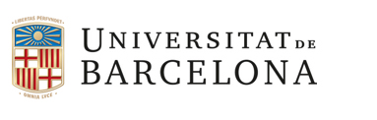
4.International Consulting and Mobility Agency (INCOMA), Spain | 5.Agencia Nacional de Evaluacion de la Calidad y Acreditacion (ANECA), Spain

PARTNER COUNTRY

6.Hanoi University (HANU), Vietnam | 7.Posts and Telecommunications Institute of Technology (PTIT), Vietnam
8.National University of Art Education (NUAE), Vietnam  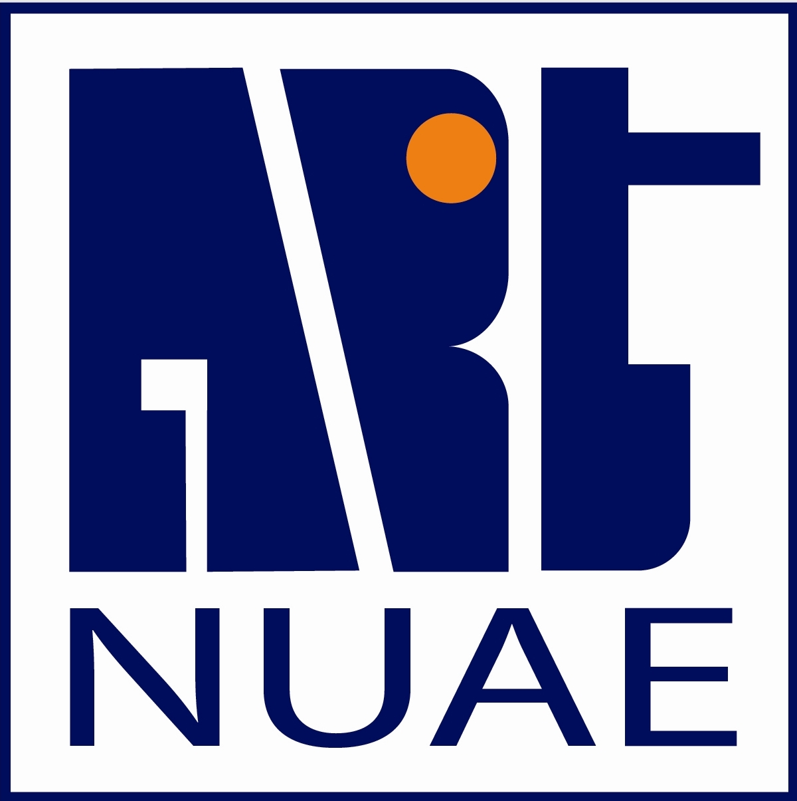 | 9.Vietnam National University of Agriculture (VNUA), Vietnam
10.Thai Nguyen University (TNU), Vietnam | 11.Academy of Journalism and Communication (AJC), Vietnam  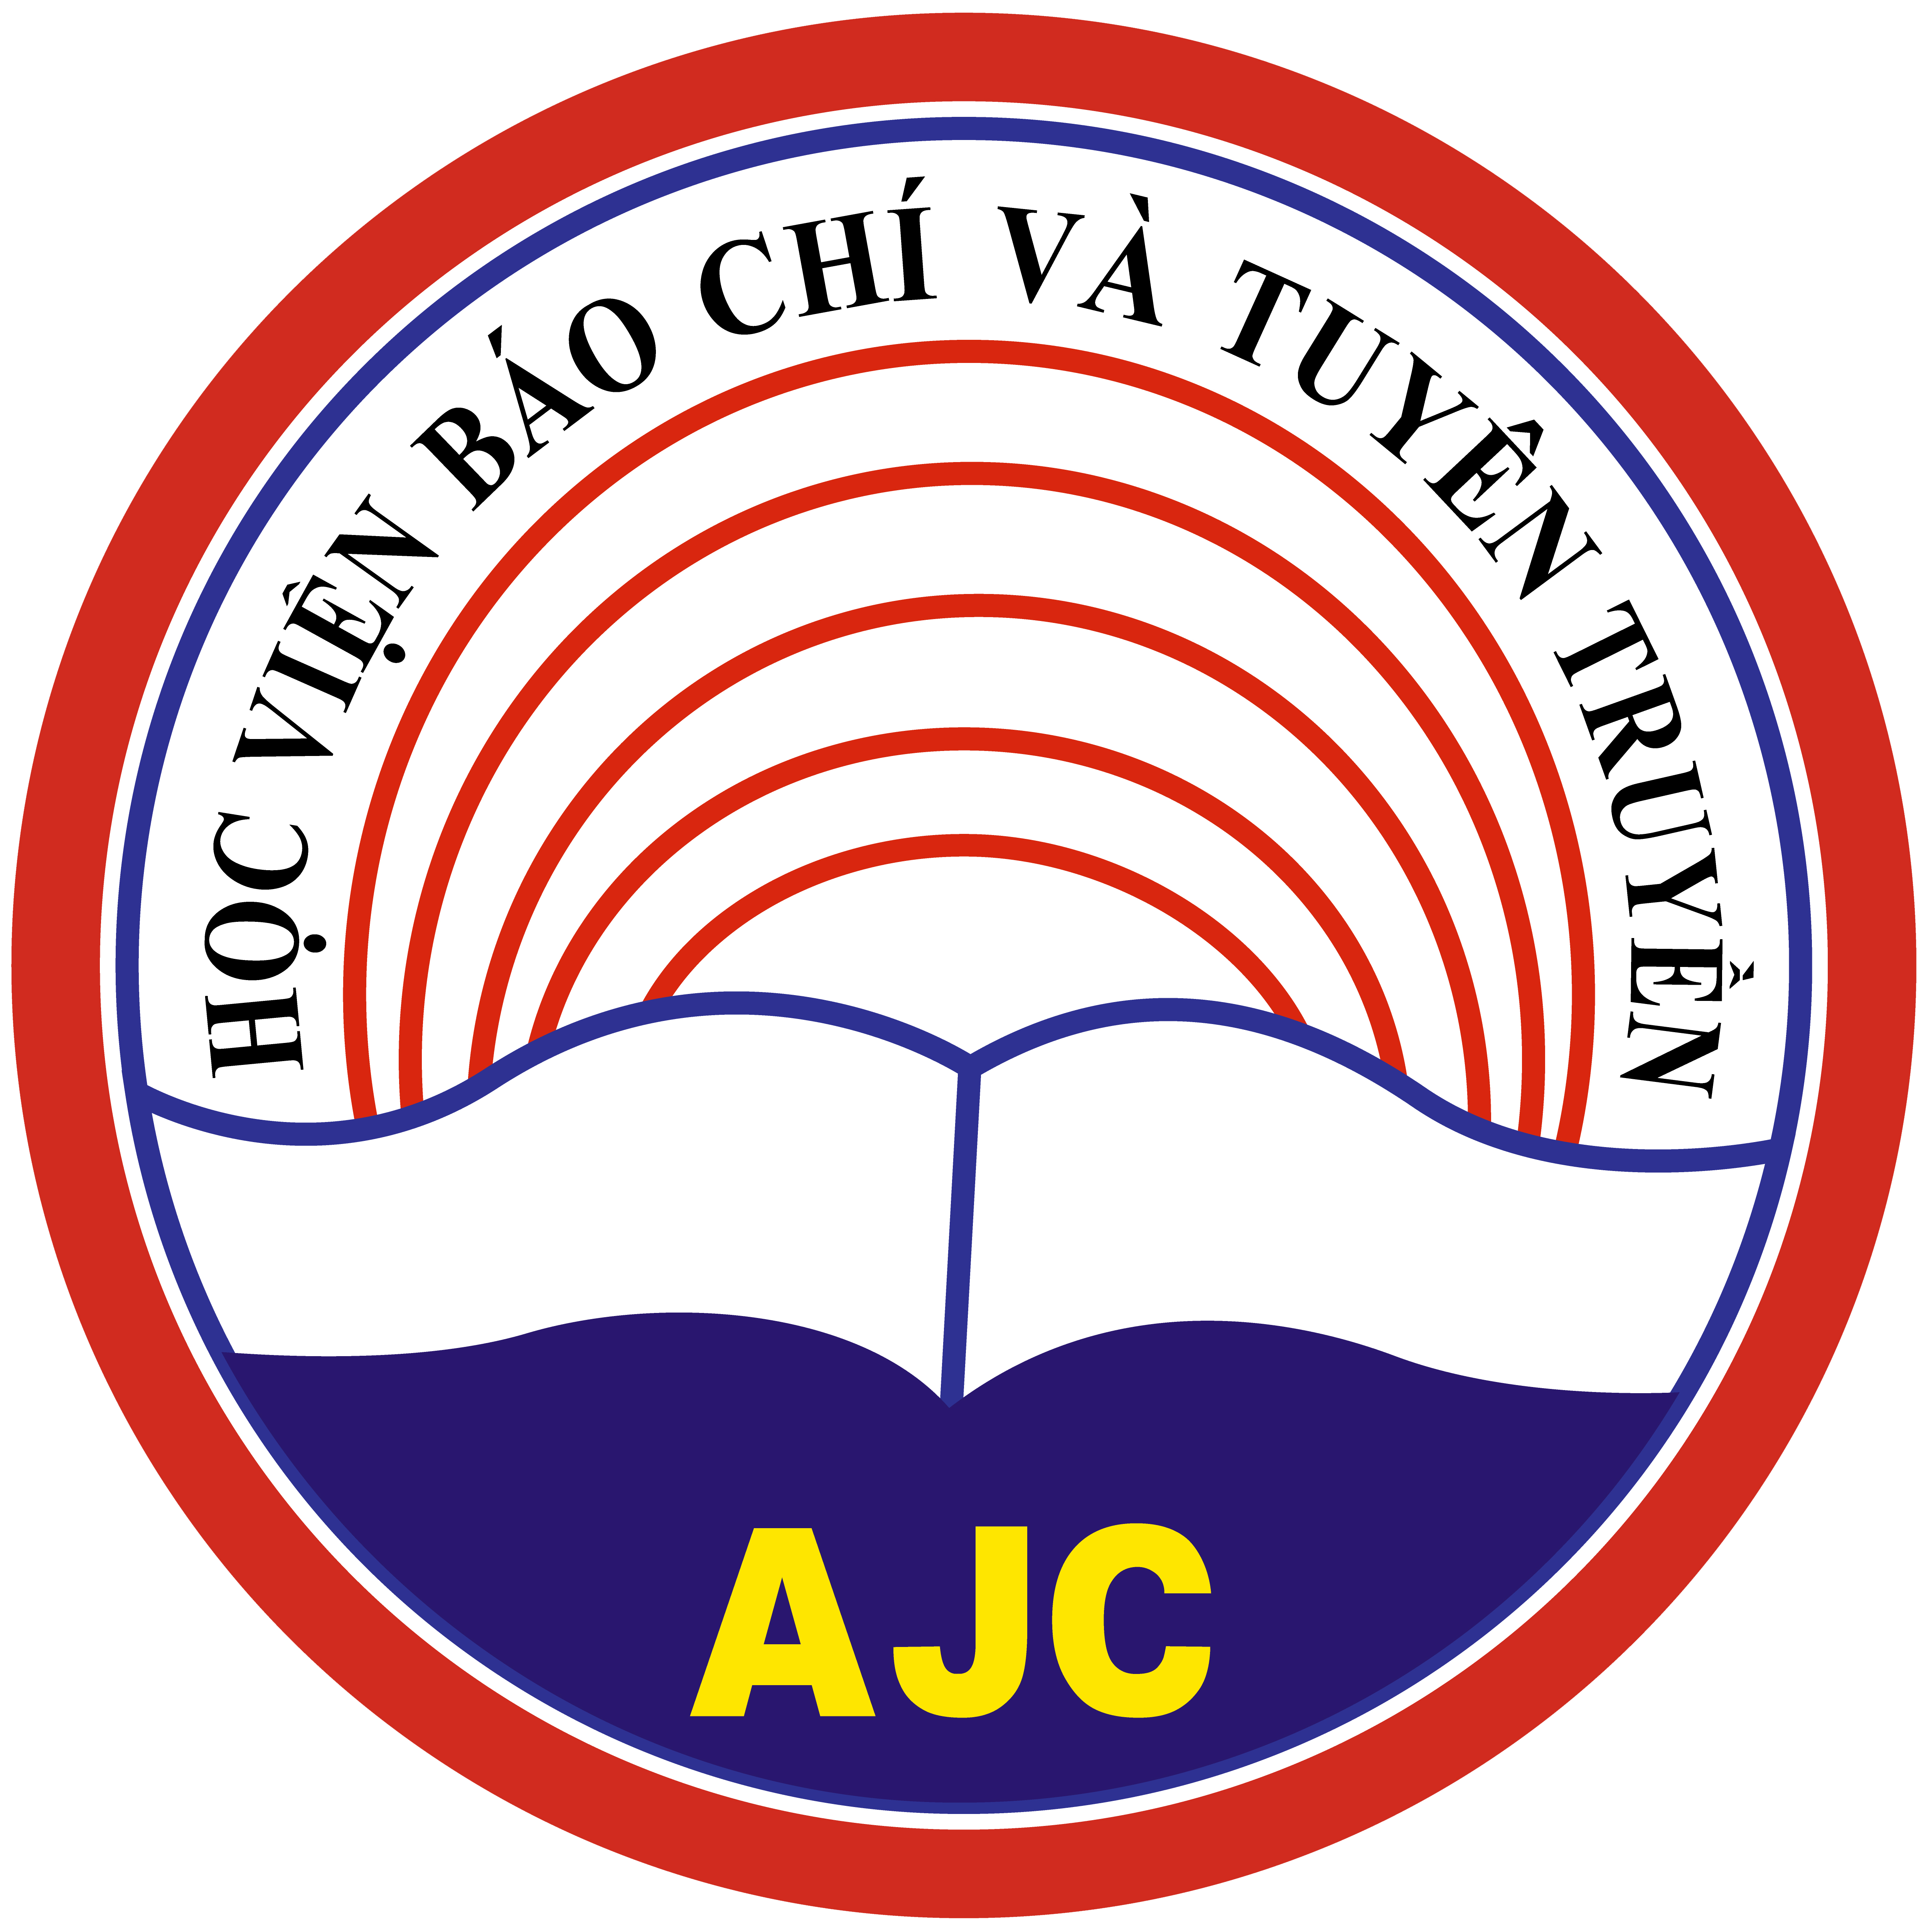
12.Hanoi University of Home Affairs (HUHA), Vietnam | 13.Hanoi Tourism College (HTC), Vietnam
14.Halong University (HALOU), Vietnam | 15.Ministry of Education and Training ( MOET), Vietnam
16.Hanoi Small and Medium Enterprises Association (HanoiSME), Vietnam | Associate partner: Ho Chi Minh Open City University (OU), Vietnam
PLENARY 1

24 FEBRUARY 2020

9.00 - 9.30 | Registration of participants
9.30 – 11.00 | Welcome address  Prof. Marina Timoteo, AlmaLaurea Director  Mr. Bui Van Linh, Director of department of Political Education and Students Affairs Ministry of Education and Training of Vietnam  Vietnamese partners presentations:  HANU: Prof. Nguyen Van Trao  PTIT: Prof. Vu Tuam Lam  NUAE: Prof. Dao Dang Phuong  TNU: Prof. Tran Thanh Van  HALOU: Prof. Phan Thi Hue  AJC: Prof. Luu Van An  VNUA: Prof. Pham Bao Duong  HTC: Prof. Trinh Cao Khai  HUHA: Prof. Nguyen Ba Chien  HanoiSME: Mr. Mac Quoc Anh  HCMCOU (Associated partner): Prof. Le Thi Thanh Thu  EU partners presentation:  FH Joanneum: Mr. Dimitrios Doukas  ANECA: Mr. Rafael Llavori de Micheo  INCOMA: Mr. Juan Guerrero Caballero  AlmaLaurea: Mrs. Malgorzata Dudko
11.00 - 11.30 | Coffee break
11.30 – 13.00 | Introduction to the meeting and MOTIVE project overview  1st presentation  Topics: Project rationale, Objectives, Expected results, Work packages, Deliverables and indicators  2nd presentation  Topics: Partner role, Gantt & mobility schedule  AlmaLaurea
13.00 – 14.00 | Lunch
14.00 – 14.15 | MOTIVE-LAB MOVIE: Erasmus+ Projects Synergies in Vietnam  STEPS Srl: Mr. Roberto Righi
14.15 – 15.30 | MOTIVE Project: Focused Sessions  1st presentation  MOTIVE project website presentation  2nd presentation  Dissemination and Sustainability  AlmaLaurea, AJC, HANU, MOET
15.30 – 16.00 | Coffee break
16.00 – 16.30 | MOTIVE Project: Next Steps  WP 1.1, 1.2 and 1.3: Horizontal training for IT, researchers and administrative staff  WP 5.3: Handbook of best practices for dissemination  Next meeting planning  AlmaLaurea
16.30 | Open discussion and meeting conclusion
19.00 | Social Dinner, “Officine degli Apuli” Restaurant, Via San Lorenzo 4.
Vietnamese-English and English-Vietnamese simultaneous translation will be available

PLENARY 2

25 FEBRUARY 2020
-First Steering Committee, Management and Financial Meeting-

9.00 - 9.30 | Registration of participants
9.30 – 11.00 | Financial management  1st presentation  General framework: Erasmus+ Programme guide; EACEA Grantholders meeting contents and reccomendation (Brussels, 27-28 January 2020)  2nd presentation  Financial management for budget headings:  Staff costs  Travel Costs  Costs of stay  Subcontracting  Equipment Purchase  AlmaLaurea, Project Consortium
11.00 – 11.30 | Coffee Break
11.30 – 13.00 | MOTIVE Project Partnership agreements  PA presentation  Dorel Manitiu  Open Discussion
13.00 – 14.00 | Lunch
14.00 – 15.30 | Project Quality: main tools of implementation  1st presentation  Focus on project quality  2nd presentation  Quality plan presentation  AlmaLaurea, UB
15.30 – 16.00 | Coffee break
16.00 | Open discussion and plenary meeting conclusion
Vietnamese-English and English-Vietnamese simultaneous translation will be available

26 FEBRUARY 2020

-Working Groups Meeting-

Meeting point: Viale Angelo Masini 36, Bologna, at 9.30 AM

10.00 – 12.30 | IT and Research groups meeting (1)  Planning and content discussion of WP 1.1, 1.2 and 1.3: Horizontal training for IT, researchers and administrative staff
 | Lunch
14.00 – 15.30 | Working groups meeting for project parallel sessions  Bilateral meeting with European partner  Bilateral meeting with Vietnamese partners
15.30-16.30 | Presentation of the Almalaurea Graduate tracking report  AlmaLaurea
16.30 | Open discussion and working groups meeting conclusion

27 FEBRUARY 2020

University of Bologna, Department of International Relations, Via Filippo Re

Meeting point: Via Filippo Re, Bologna at: to be confirmed by DIRI

10.00 | Workshop at International Department of University of Bologna (DIRI)  Perspectives of new cooperation between Vietnamese Universities and University of Bologna
 | Coffee break
14.00 | Visit at University of Bologna, Rectorate

